**E-PROJECT: whoZThat**

**whoZThat**

**USERS GUIDE**

|  |  |  |
| --- | --- | --- |
| **SUPERVISOR** | TAHA ABBAS ALI | |
| **BATCH CODE** | 2501B2 | |
| **GROUP** | B | |
| **SERIAL NO** | **ENROLLMENT NUMBER** | **STUDENT NAME** |
| **1** | Student1633780 | Abdullah |

**E-PROJECT: whoZThat**

**Navbar:**

**Navbar contains of the following links:**



* [Personal](http://127.0.0.1:5500/index.html?#personal)
* [Education](http://127.0.0.1:5500/index.html?#education)
* [Career](http://127.0.0.1:5500/index.html?#career)
* [Achievements](http://127.0.0.1:5500/index.html?#achievements)
* [Nobel Work](http://127.0.0.1:5500/index.html?#nobel)
* [Books](http://127.0.0.1:5500/index.html?#books)
* [Summary](http://127.0.0.1:5500/index.html?#summary)
* [FAQs](http://127.0.0.1:5500/index.html?#FAQs)

**Personal:**

What This Section Covers:  
An overview of Dr. Abdus Salam’s early life, identity, and personal milestones.

**E-PROJECT: whoZThat**

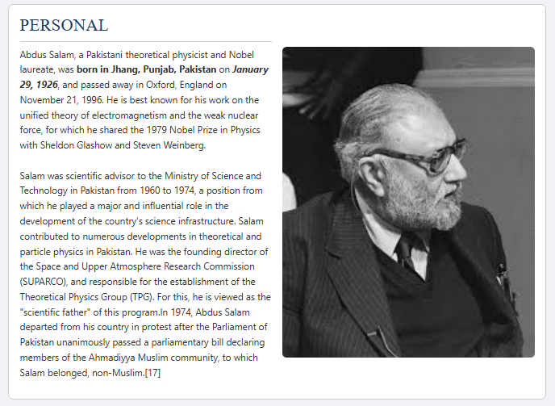

**Key Information:**

* Born: January 29, 1926, in Jhang, Punjab, Pakistan
* Died: November 21, 1996, in Oxford, England
* Renowned for: Unified theory of electromagnetism and the weak nuclear force
* Notable Roles: Scientific advisor to the Pakistani government, founding director of SUPARCO

**E-PROJECT: whoZThat**

* Social Context: Left Pakistan in 1974 after the Parliament declared Ahmadis as non-Muslims

*Use this section to understand the personal and cultural context of Dr. Salam’s journey.*

**Education:**

What This Section Covers:  
Academic background and progression.

Key Information:

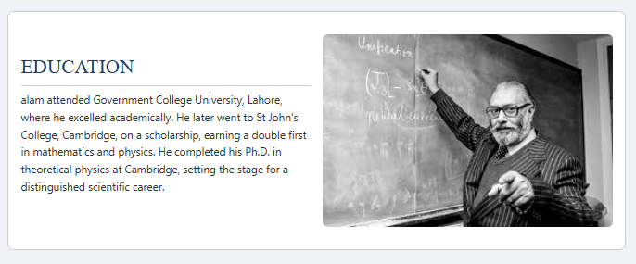

* Undergraduate: Government College University, Lahore

**E-PROJECT: whoZThat**

* Higher Studies: St. John’s College, Cambridge (Double First in Math & Physics)
* Ph.D.: Theoretical Physics at Cambridge

*Explore how academic excellence set the stage for Salam’s scientific contributions.*

**Career:**

What This Section Covers:  
Professional roles, affiliations, and scientific leadership.

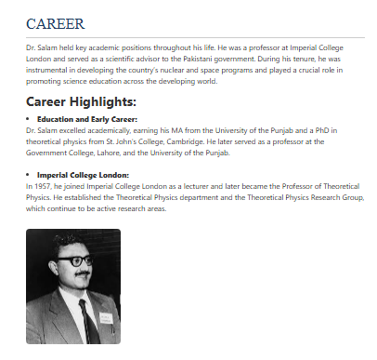

**E-PROJECT: whoZThat**

**Key Highlights:**

* Taught at Government College, Lahore and University of the Punjab
* Professor at Imperial College London – founded Theoretical Physics Group
* Advisor to Pakistan’s science initiatives, helped shape nuclear and space programs

*Understand how Salam's academic career led to global scientific influence.*

**Achievements:**

What This Section Covers:  
Awards, honors, and global impact.

**E-PROJECT: whoZThat**

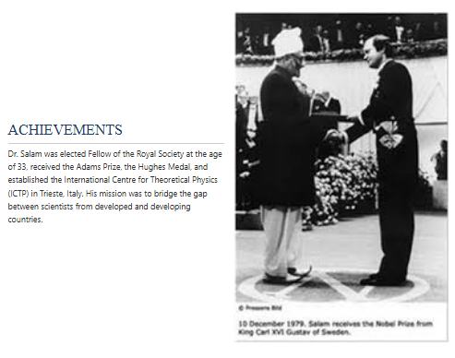

**Major Achievements:**

* Elected Fellow of the Royal Society at age 33
* Winner of the Adams Prize & Hughes Medal
* Founded the International Centre for Theoretical Physics (ICTP)

*Check this section to learn about Salam’s scientific leadership and honors.*

**Nobel Work:**

**E-PROJECT: whoZThat**

What This Section Covers:  
Details of his Nobel-winning research and scientific contributions.

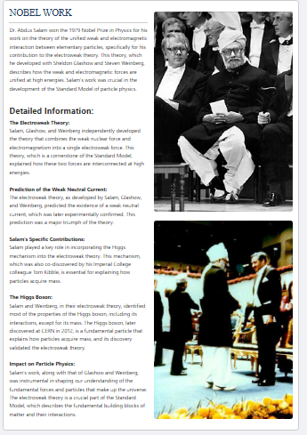

**Key Contributions:**

* Electroweak Theory: Unified weak nuclear force and electromagnetism
* Co-recipients: Sheldon Glashow and Steven Weinberg

**E-PROJECT: whoZThat**

* Integrated the Higgs mechanism into the theory
* Predicted weak neutral currents—later confirmed experimentally
* Paved the way for discovery of the Higgs Boson

*This section explains why Salam's work was revolutionary for modern physics.*

**Books:**

What This Section Covers:  
Books written by or about Dr. Salam.

**E-PROJECT: whoZThat**

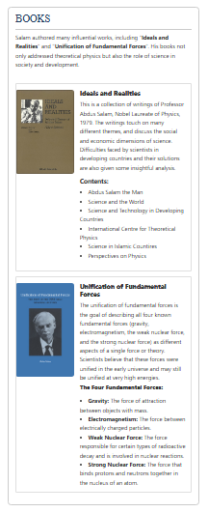

**Featured Titles:**

* "Ideals and Realities": Covers science and its role in society and developing countries
* "Unification of Fundamental Forces": Explores the unification of the four fundamental forces

*Use this section to find resources for deeper understanding and research.*

**Summary:**

**E-PROJECT: whoZThat**

**What This Section Covers:**  
A brief recap of Dr. Salam’s life and work.

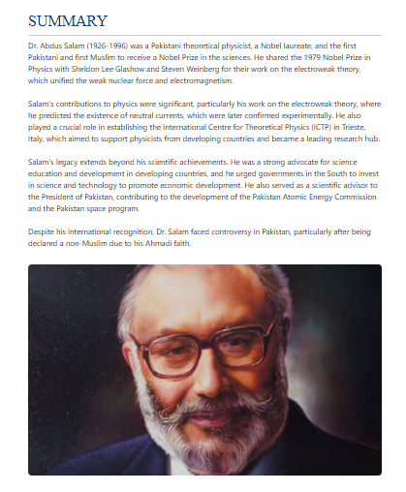

**Summary Points:**

* First Pakistani and Muslim to win a Nobel Prize in science
* Pioneer of electroweak unification
* Founder of ICTP

**E-PROJECT: whoZThat**

* Advocate for science in developing countries
* Faced religious discrimination in Pakistan

*Quick reference to understand Dr. Salam’s overall impact and legacy.*

**FAQs:**

What This Section Covers:  
Common questions and factual clarifications.

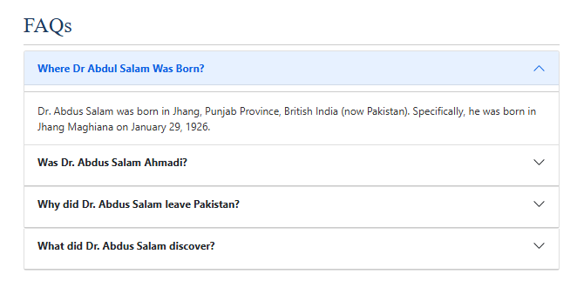**Sample Questions Covered:**

* Where was Dr. Abdus Salam born?

**E-PROJECT: whoZThat**

* Was he Ahmadi?
* Why did he leave Pakistan?
* What did he discover?

*Helpful for students, researchers, and curious readers seeking fast answers.*

**Feedback Form:**

What This Section Covers:  
Allows users to share feedback or ask questions.

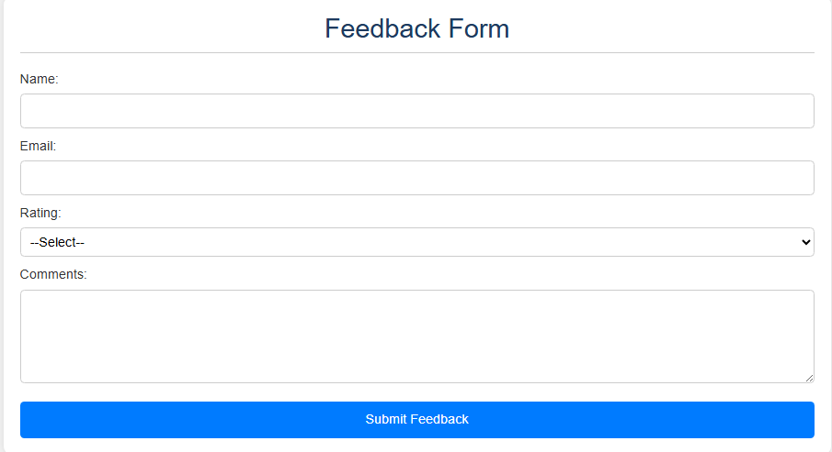

**E-PROJECT: whoZThat**

**Form Fields:**

* Name (text input)
* Email address (text input)
* Feedback (text area**)**
* RATING (rating area)

We welcome your input to help us improve whoZThat.

**FOOTER:**

The footer of the biography website is designed to provide quick access to essential information and navigation links, as well as offer a convenient way to get in touch or stay connected. Here's a breakdown of what you'll find in the footer and how to use it effectively.

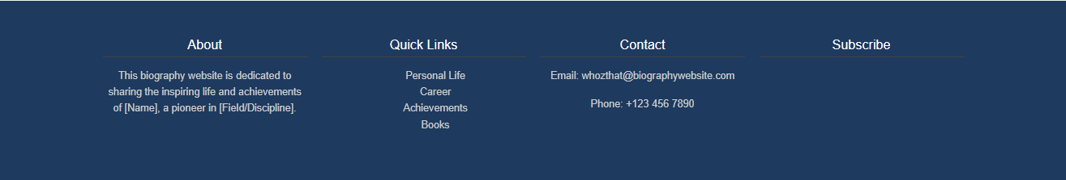

#### **Purpose of the Footer:**

The footer serves as a consistent, always-available section at the bottom of each page. It helps users:

* Navigate to key parts of the website
* Contact the website team directly
* Learn more about the site’s purpose
* Subscribe for updates